MEDIA RELEASE:
Conflagration
Jala Wahid’s first institutional solo exhibition in Scotland
Preview: Friday June 23rd 2023, 7:00pm to 9:00pm
Exhibition runs until 10th September 2023
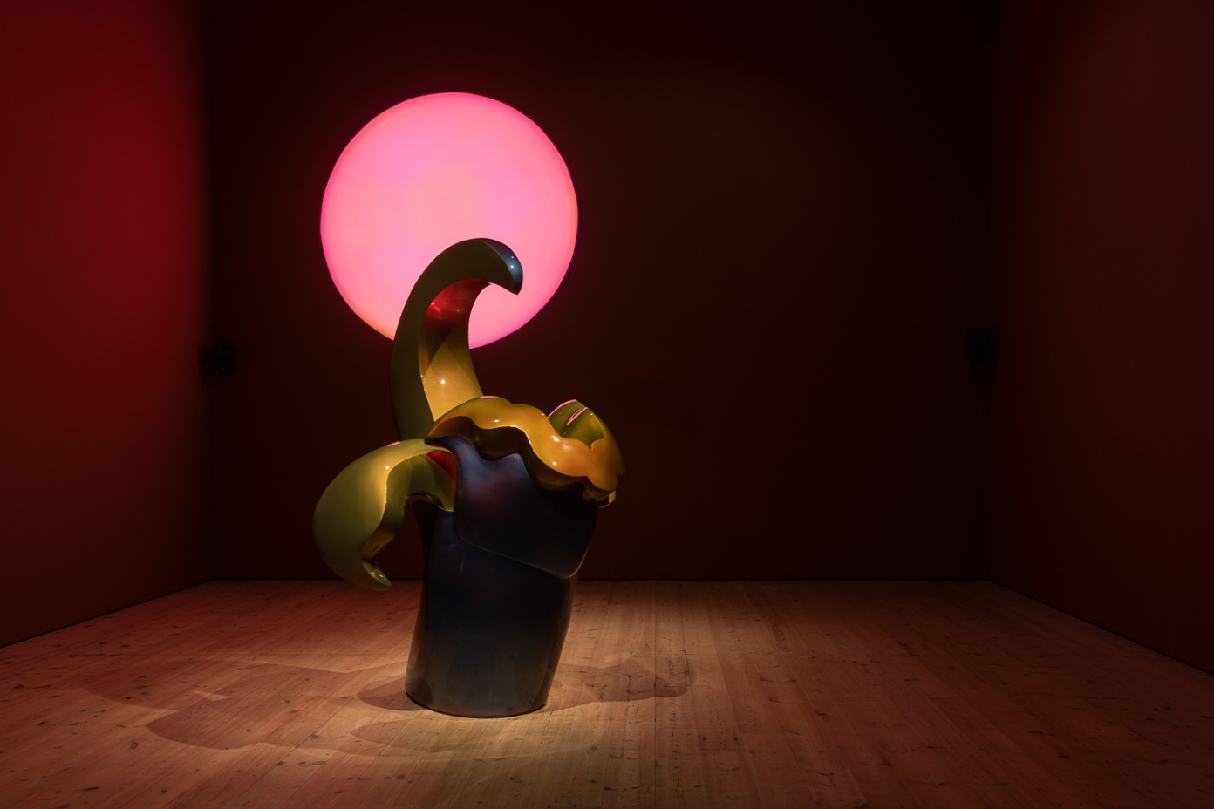
Jala Wahid, ‘Conflagration’, 2022, installation view BALTIC. Courtesy: the artist and BALTIC

Tramway in Glasgow will launch its latest exhibition, Conflagration – artist Jala Wahid’s first institutional solo exhibition in Scotland – on Friday 23 June and running until 10 September.

Jala Wahid makes work that touches on urgent issues in relation to identity, nationhood, diasporic living, diasporic living in the UK, intergenerational connections and cultural traditions. She considers how politics and poetic expression interweave. Wahid looks to embody this intertwining in her work by exploring its urgency, defiance, euphoria and violence to suggest ways of being that challenge fixed definitions of identity. Conflagration presents a new body of work exploring the relationship between Britain and Kurdistan, through the lens of oil. The installation approaches oil as the symbolic material through which nationalism, statelessness, colonialism and Kurdish identity are explored. It is grounded in the discovery of the Baba Gurgur oil well, following a time during which Britain and France politically occupied Mesopotamia, culminating in the formation of new nation states in the region’s oil resources.
In Conflagration, Wahid invites us to step into a landscape conceived as an inferno. It is unclear whether we’re beneath the ground in an oil well, amidst the burning refineries, or within columns of smoke resulting from gushers or oil fires during conflict and war.
More Information on Work
The light sculpture titled Sick Pink Sun (03:00 14.10.1927 - ) commemorates the precise moment the first well in the Baba Gurgur field was struck and points to an unknowable future in the wake of the oil industry. Until 1948, Baba Gurgur was considered the largest oil field in the world. It is situated in the Kirkuk province, a region disputed between Federal Iraq and the Kurdistan Region. This history and current politics are explored through Naphtha Maqam, a sound work created from archival material found in the National Archives and the British Petroleum archives. Wahid has collaborated with sound producer Owen Pratt and Amal Saeed Kurda, a well-known contemporary Kurdish singer/composer, to produce a funereal maqam, melodically Kurdish but lyrically English. Naphtha Maqam includes other elements such as recordings of oil drilling rigs, as well as Wahid’s own voice.
Prior to drilling, Baba Gurgur has been naturally burning for 4,000 years; its mythological and symbolic cultural history is also explored in the exhibition. The Salvia spinosa flower, endemic to the region, is central to the exhibition and Wahid presents it as the embodiment of the Baba Gurgur gusher. In producing a single sculpture, Wahid aims to play into the idea of monument. The Salvia spinosa flower exists in abundance and is the only species of flora to be specifically described as growing on shale rocks in-between oil wells at Baba Gurgur. A new-to-science species of the Salvia plant was recently discovered in Kurdistan. The parallel discovery of oil, flora and identity is important for Wahid. She asks what makes a discovery symbolic, what are its implications, and at what or whose expense?
Jala Wahid: Conflagration has been co-commissioned by TRAMWAY and BALTIC Centre for Contemporary Art

Recent solo exhibitions include: 2023 ‘Mock Kings‘, Kunstverein Freiburg (DE); 2022 ‘Conflagration‘, BALTIC Centre for Contemporary Art, Newcastle (UK), ‘Aftermath’, Niru Ratnam Gallery, London (UK); 2021 ‘Rock Fortress’, CAS Batumi, Batumi (GE), ‘Cry Me a Waterfall‘, Two Queens, Leicester (UK); 2020 ‘Rock Fortress’ E.A. Shared Space, Tbilisi (GE); 2019 ‘Newroz’,

Image Credit: Jala Wahid, ‘Conflagration’, 2022, installation view BALTIC. Courtesy of the artist and BALTIC

For press information contact Nicola Jeffs nj@nicolajeffs.com
Mobile: 07794 694 754

Funded by Creative Scotland

About Tramway
One of Scotland’s leading international art-spaces, the venue acts as a hub for creative excellence in contemporary visual art and performance by developing presentation and production opportunities supporting ambitious commissions and the production of new exhibitions by both Scottish and International artists.
Visit www.tramway.org

About Glasgow Life
Glasgow Life is a charity working for the benefit of the people of Glasgow. We believe everyone deserves a great Glasgow life and we find innovative ways to make this happen across the city’s diverse communities. Our programmes, experiences and events range from grassroots community activities to large-scale cultural, artistic and sporting events which present Glasgow on an international stage. Our work is designed to promote inclusion, happiness and health, and to support the city’s visitor economy in order to enhance Glasgow’s mental, physical and economic wellbeing.
Visit www.glasgowlife.org.uk

