Media release

RENOWNED SCOTTISH ARTIST NORMAN GILBERT HAS MAJOR CAREER SPANNING SHOW AT TRAMWAY THIS AUTUMN

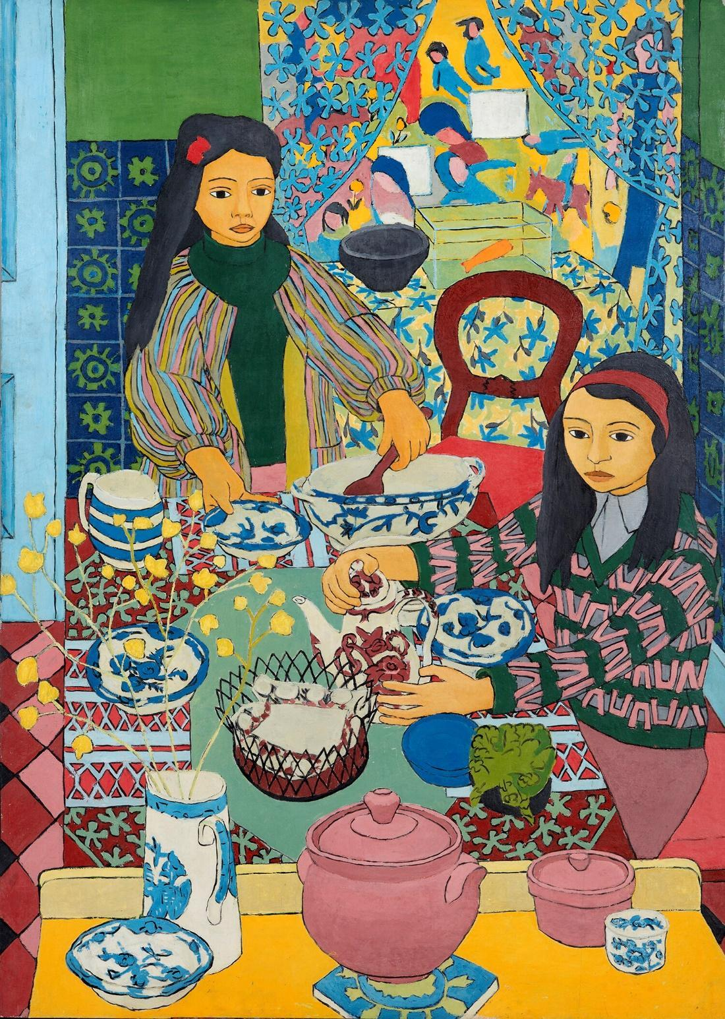

OPEN 3rd SEPTEMBER 2022 – 5th FEBRUARY 2023
PRESS CALL - 10AM - 11.30AM FRIDAY 2ND SEPTEMBER
PREVIEW - 7-9PM FRIDAY 2ND SEPTEMBER

Norman Gilbert (1926-2019) lived and worked on Glasgow’s south side for over sixty five years painting intimate, domestic scenes of his wife Pat, their four children and an extended family of friends and neighbours who frequented their home on Shields Road, and enriched and shaped their lives. Tramway is pleased to present the first solo exhibition of his work, in his home city and neighbourhood.
Gilbert’s vibrant and formally diverse paintings are characterised by bold, inventive colour palettes and flat areas of vivid pattern that sit next to one another in exuberant combinations. Intricately detailed and complex in their composition, his paintings deftly shape a fluid synthesis between figure and space, creating a sense of wholeness in which people, objects and their environments exist harmoniously. In Gilbert’s own words “each colour and shape enhances every other colour and shape, so it’s entirely satisfactory, so it’s at peace.”
Along with Norman Gilbert's paintings, Tramway are also exhibiting pencil studies as well as textiles, objects and ephemera from the artist’s studio which was just moments from Tramway. Murals and elements of the painting have also inspired the scenography of the exhibition.
Using pattern to dynamic effect, Gilbert democratically embellishes every intricate detail of the painting, exaggerating outlines and contours to build depth and spatial complexity. This technique combined with his inventive narrative eye draws audiences into the paintings inviting them into Gilbert’s world in which the daily rhythms and intimacies of family life are teased out.
Gilbert’s studio was based in the family home and the interlacing of pattern and motif echo the confluence of art and life which defined Gilbert’s process. From the 1970’s fashions of his teenage children and printed textiles created by his wife Pat, to the architectural motifs of their Victorian tenement, Gilbert’s paintings are steeped in domestic life. Everyday family scenes from the banal to the touchingly poignant are played out as if on a stage, blurring the lines between art and life, and challenging what might be considered a valuable or important subject for a painting.
Perhaps most poignantly Gilbert’s work has also come to mark the passage of time, as fashions change and children grow, his subjects age and life unfolds. Notably his works feature his four sons as they grew up, formed relationships, and had children of their own. He also painted many portraits of his wife Pat, continuing into old age in paintings such as ‘Chair’ or ‘Pat’ characteristically titled simply but evoking in them the complex intimacies and inner emotional worlds that make up a life. In the words of his son Mark “Dad’s pictures are a tender and affectionate testament to his life and the relationships that nourished him.”
Gilbert continued to paint in his nineties through the final years of his life, and in the absence of people to sit for paintings, he turned to his garden and nature, making beautifully detailed pictures of plants. He also carried on painting the objects that have been familiar constants in his work over the years, the same chairs, tables, ceramics, and textiles which feature repeatedly in his paintings, yet always imbuing them with a new narrative and interpretation. The works on easels ‘Plants, Patchwork and Two Green Chairs were the final paintings Gilbert made at the age of 92 and the paintings colours can be seen in his palette presented alongside the works in the exhibition.
Whilst displaying a joyful vivacity which defies adherence to formalist trends, each painting is also testament to Gilbert’s rigour and dedication to his practice over his 70 year career. His canvases were created over months through a meticulous process in which Gilbert first created the painting as a pencil drawing, following this as a black and white painted study before moving on to the final version in colour. Many of the black and white studies, incredible paintings in their own right, are exhibited here at Tramway.
https://www.normangilbert.com/
https://www.normangilbert.com/media
Norman Gilbert (1926-2019) attended the Glasgow School of Art where he was accepted in 1948 and laid the foundation for his painting style—one that has been evolving and developing ever since. In 1967 the Upper Grosvenor Gallery mounted his first solo exhibition. In 1974 Norman’s work was the subject of a BBC film as part of a series of arts programs entitled “SCOPE,” presented by the critic and writer W. Gordon Smith. The broadcast coincided with his solo show in the Edinburgh Talbot Rice Centre. To date Norman has had fourteen solo shows, in addition to many group exhibitions. In 2018 he was the subject of a BBC Scotland Loop documentary:

https://www.youtube.com/watch?v=qW2pAGegZvI

For media information contact

Nicola Jeffs
nj@nicolajeffs.com
07794 694 754

About Tramway
Tramway is an international contemporary arts hub which supports established and emerging artists, both international and local, who focus on experimental and contemporary dance, visual art and performance. For thirty years we have built a reputation for our unique performance and exhibition spaces, and ambitious and inspiring programming.
Tramway is a Creative Scotland regularly funded organisation and part of Glasgow Life
www.tramway.org
About Glasgow Life
Glasgow Life is a charity working for the benefit of the people of Glasgow. We believe everyone deserves a great Glasgow life and we find innovative ways to make this happen across the city’s diverse communities.
Our programmes, experiences and events range from grassroots community activities to large-scale cultural, artistic and sporting events which present Glasgow on an international stage.
Our work is designed to promote inclusion, happiness and health, as well as support the city’s visitor economy, in order to enhance Glasgow’s mental, physical and economic wellbeing.
For more information on our work, see www.glasgowlife.org.uk

IMAGES WITH CREDITS:

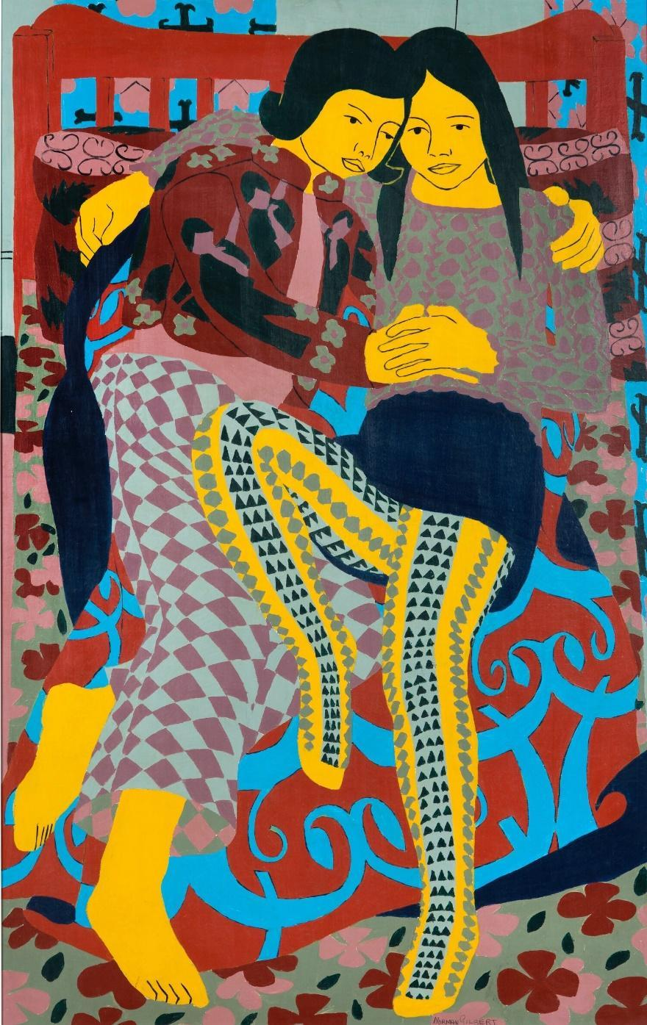

Reclining Boy and Girl', Oil on Board,122x76cm, ©Norman Gilbert, 1971

'Dymphna and Vianni', Oil on Board, 122 x 88cm, © Norman Gilbert, 1967

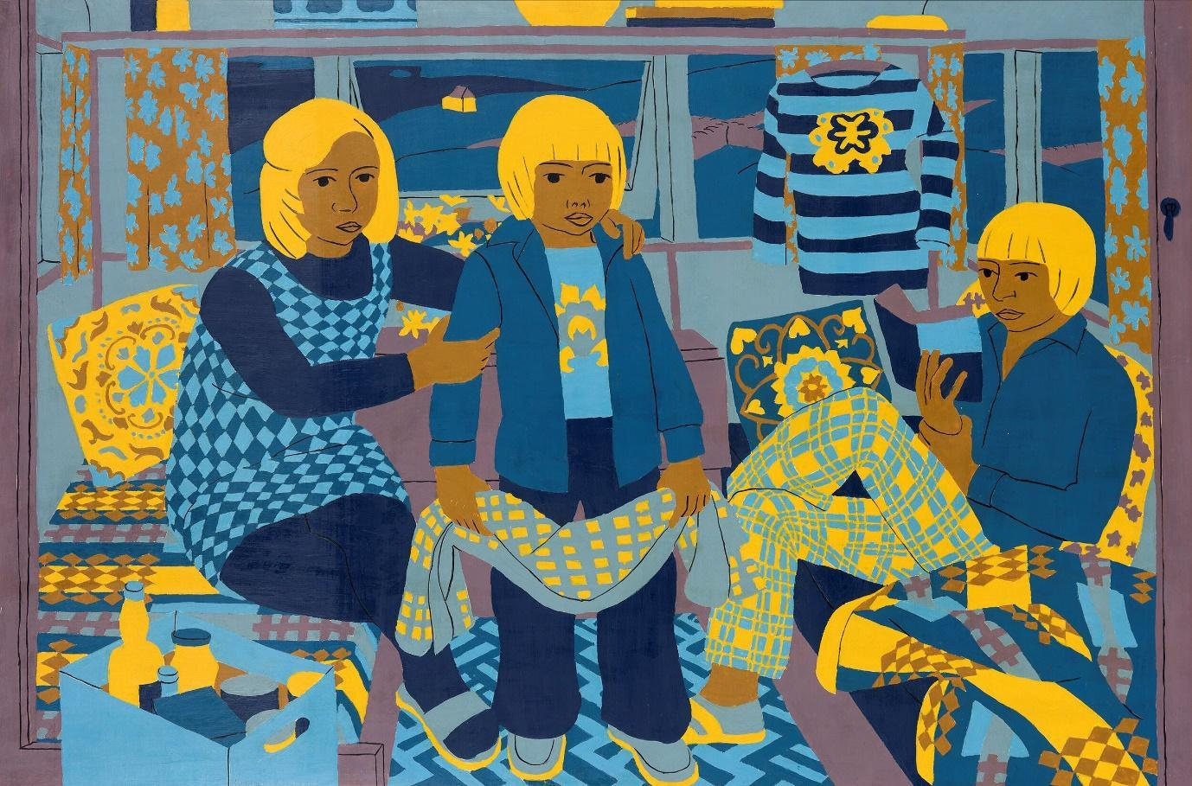

'Holiday Caravan', Oil on Board,81x122cm,©Norman Gilbert, 1975

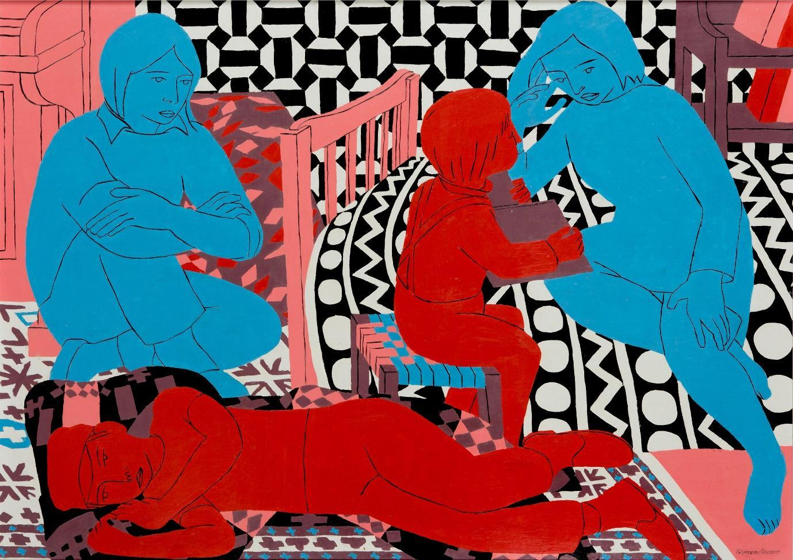

'People and Black and White Patterns', Oil on Board, 86x122cm, © Norman Gilbert, 1972

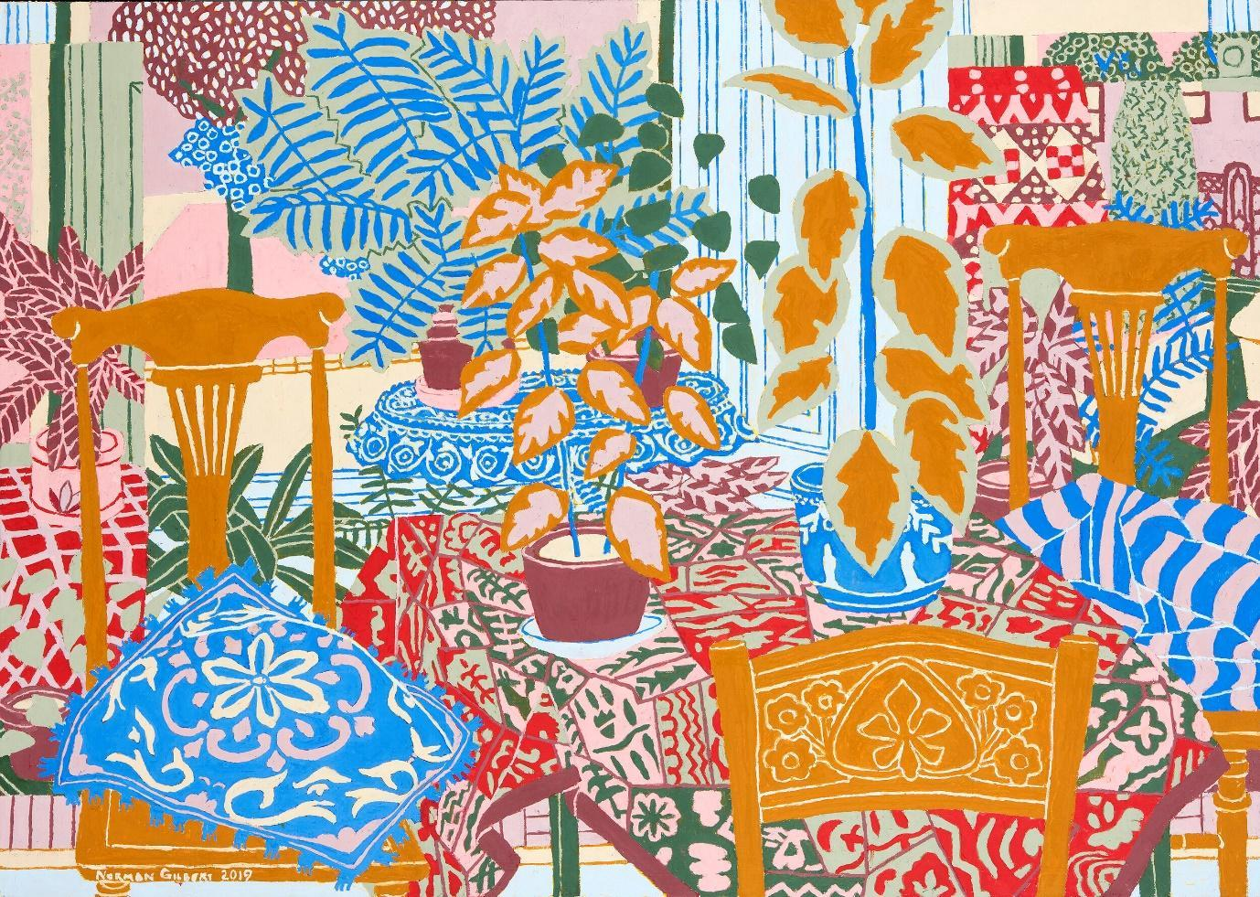

'Three Chairs and Plants', Oil on Board, 86x122cm, ©Norman Gilbert, 2019

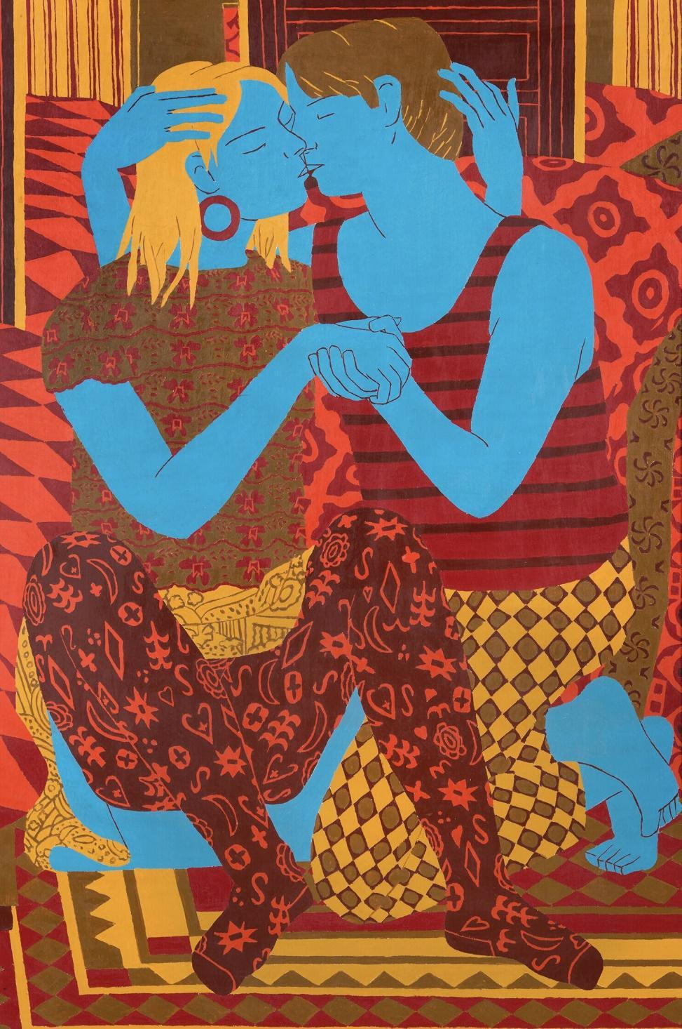

'Embrace II', Oil on Board, 122x81cm,1990

