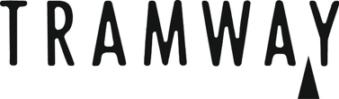

We work hard to identify and remove any barriers marginalised people encounter in the arts. As part of this it is important for us to keep track of who is, and is not, applying for our various opportunities, in order to better develop our work for the future. In some occasions it is also helpful to know if aspects of your proposed project are informed by your lived experience and personal identity. These questions are optional to fill out (leave any you wish to blank or write ‘prefer not to say’ - no assumptions will be made).

How would you describe your gender?

_________________________________

Is your gender different to one assigned at birth?

_________________________________

How would you describe your racial identity and ethnic background?

_________________________________

Do you identify as deaf?

_________________________________

Do you identify as disabled?

_________________________________

Do you identify as neurodivergent?

_________________________________

How do you define your socio-economic status (class)?

_________________________________

Are you a parent or carer?

______________________________
Have you experienced any barriers due to any other aspect of your lived experience of personal identity? Please give as much information as you like.

_______________________________________

