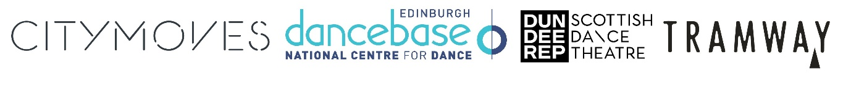
Recipients of #LoveDanceScotland Recovery Bursaries announced
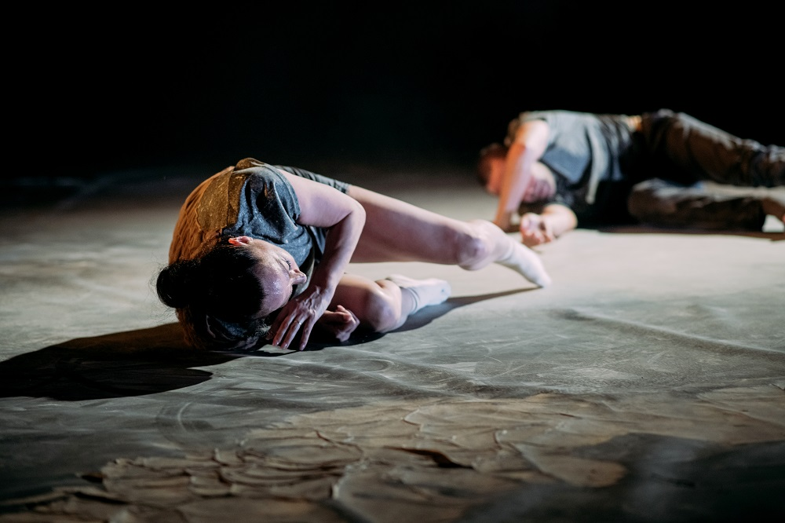
Some of Scotland’s leading dance organisations – Citymoves Dance Agency, Dance Base Scotland, Dundee Rep & Scottish Dance Theatre and Tramway – are pleased to announce the names of the twelve dance artists receiving the #LoveDanceScotland Recovery Bursaries, a unique programme of support for artists as they return to their practice post-lockdown.
White & Givan, credit Mikaela Bodlovic

After the success of #LoveDanceScotland Commissions, some of the country’s leading dance institutions and organisations have teamed up again to offer the #LoveDanceScotland Recovery Bursaries, highlighting the importance of working in partnership, and enabling artists to take the lead by designing their own recovery programme. #LoveDanceScotland is a nationwide programme of in-kind and financial support for Scotland-based professional dance artists, providing the time and space for them to re-engage with their creative practice after the very challenging 18 months.
Artists receiving the Bursary are devising and delivering a project either digitally or in-person which will take place between October and January 2022 with each project involving an element of audience engagement to help artists, audiences and venues reconnect after this period of separation. From supporting research and development to mental and physical recovery, from Joan d’Arc to domestic violence, from working in communities to forging new creative connections, the Bursaries are set to support twelve artists living and working in different areas of Scotland and at different stages of their careers. A total fund of £70,000 has been allocated and a brief overview of the projects below, please see Notes to editors for more information.
- Andre Anderson presents a new, interactive, intergenerational performance experience aimed at children under the age of 5: Playing Together. Visiting New Galloway’s CatStrand on 13 and 14 November, the show is about the power of play and its importance for everyone recovering from the effects of the global pandemic
- Aniela Piasecka shares her new work-in-progress, developing spatial strategies with two Scottish dance artists with experience of fibromyalgia/chronic pain as consultants and designing prototypes of soft sculptural structures with sculptor Paloma Proudfoot to create resting resources for prospective audience members.
- Dance Ihayami and Priya Shrikumar present A Happy Namaste which will see them working with older Asian women to explore key moments in their migration to the UK using music, storytelling and movement. Priya will also create a new solo work alongside those created by the older dancers and bring in a live musician for a sharing or presentation of the works.
- Grace Turner with TurnAround Dance Theatre present REignite (working title) - an aerial dance and theatre piece which focuses on how the pandemic has affected women’s views on their safety inside and outside of their homes, exploring themes such as coercive control, domestic abuse and female empowerment. Grace will lead an aerial dance workshop at Dance Base in January and a sharing on 14 January.
- Jack Webb will be engaging in a 4-week solo project that focusses on the return to the dancing body, re-establishing his practice as a choreographer and dancer.
- Jemma Steinis an independent artist who plans to work with 3 other artists from across Scotland on the theme of coming home, with the project also involving workshops and developing new work with a sharing at the end which takes place at Dance Base on 12 November.
- Jenna Corker is interested in the thresholds and blending of barriers in nature, and between urban and natural spaces. She plans to spend time in coastal areas and forests around Scotland, exploring and collecting ideas to then work with pianist and composer Carla Sayers and actor and lecturer Stephanie Arsoka.
- KAM-RI Dance Theatre plan to continue the digital and live preparation of their work KILL 'EM WITH LOVE - The Fury of ARI UP of THE SLITS to make it tour-ready with digital iterations. Directed by Kerieva McCormick and in collaboration with choreographer Adesola Akinleye.
- Robbie Synge, based in Nethy Bridge in Badenoch & Strathspey, will be spending time moving and working with cameras on his own as well as continuing to build on audience opportunities that were interrupted by the pandemic.
- Skye Reynolds plans to use the Bursary to continue developing the ideas that arose whilst creating her site-responsive, family-friendly piece called #trolleyscores and saints which was inspired by St Joan of Arc and shopping trolleys and will explore using text, movement and music.
- Tess Letham focuses on improvisational performance, inspired by her training with David Zambrano. She will invite a collective of dancers to work collaboratively to share and discover each other’s practices and delve into conversations and creative activity that will develop the improvisational performance for this and future projects. Tess will share her work with audiences at Tramway on 5 December.
- White & Givan, will continue to progress their creative practice in the development of their new creation Grace, allowing time to maintain a high level of integrity.

Hayley Durward, CEO of Citymoves Dance Agency said: “We are delighted to support a breadth of Scottish based dance artists through the Creative Scotland Venues Relief Fund. The fund comes at the right time to support artists after the last 18 months of the pandemic. Partnering with 3 other Scottish dance organisations provides an opportunity to strengthen the Scottish dance sector for both artists and communities alike.”

Tony Mills, Artistic Director of Dance Base said: “From emerging talent to established choreographers working in the Borders to the Highlands, I'm really pleased with the breadth of artists the #LoveDanceScotland bursaries have been able to support. As we make our way back to a more stable performance environment, it's great that the LDS partnership has been able to act quickly to deliver significant support that promotes stability, builds confidence and contributes to creative opportunities available to artists during this period. Let's go...let's disco!”

Joan Clevillé, Artistic Director of Scottish Dance Theatre said: “We are delighted to be working again with other dance organisations in Scotland to support the independent dance community. By collaborating and pooling our resources and expertise together, we want to support artists at this critical stage of reconnecting with audiences and their own practice. For me, the breadth of artists and practices supported by the programme is a real testimony to the richness and vibrancy of the dance ecology in Scotland”.

LJ Findlay-Walsh, Tramway’s Performance Programmer said: ‘We were delighted to be able to build on the success of the last Love Dance Scotland project working swiftly to support artists in this period of 'coming back'. It felt important to have a bursary that could respond to individual artist needs; whether the wish was to pick back up where we left off or to work in new ways to new ends. Thanks goes to artist Ashanti Harris for her insight and role in supporting Tramway in this endeavour.’

#LoveDanceScotland Recovery Bursaries are supported through the Performing Arts Venue Relief Fund, thanks to support from Creative Scotland and the Scottish Government. This new fund builds on the success of the #LoveDanceScotland Commissions which were awarded in 2020.

/ENDS
Notes to editors:
Images and artists biographies: https://www.dropbox.com/sh/0rla3fawju9h42h/AABJV8o_TqbeXVHcWzDOwi0ka?dl=0
Citymoves Dance Agency
Based in Aberdeen, Citymoves Dance Agency has been leading positive impacts through dance in the North East of Scotland since 1987. The organisation encourages participation in dance for all ages and abilities - building a dance community, whilst responding to local needs and national priorities. It supports and nurtures dance talent through its professional classes, residency programme and mentoring schemes. This growing network of dance artists often perform at DanceLive Festival and become part of the fabric of our community. Through integrating professional dance artists and community participants, Citymoves aim to grow audiences for dance, developing a curiosity for the art form. The organisation has two core funders - Creative Scotland (RFO) and Aberdeen City Council; and numerous project based funders throughout the year.
https://www.citymoves.org.uk

Dance Base
As Scotland’s National Centre for Dance the organisation exists to get the whole of Scotland to experience dance and to build national and international success for dance artists based here. It has an open and accessible public programme of classes that attracts people of all ages and abilities. It has a professional programme providing mentoring, facilities and creative guidance to dance artists across Scotland, along with performance and partnership opportunities during the Edinburgh Festivals. It also promotes dance for health and wellbeing through its engagement projects, bringing together dance artists, charities, community organisations and funders to use dance effectively to deliver health and social outcomes. Dance Base is committed to developing audiences for dance and celebrating the success of the dance sector in Scotland. Dance Base is funded by Creative Scotland and The City of Edinburgh Council, with additional support from The Scottish Government Performing Arts Venues Relief Fund.
www.dancebase.co.uk/
Dundee Rep and Scottish Dance Theatre
The story of Dundee Rep and Scottish Dance Theatre is one of its people: its artists, creatives, staff, participants and audiences.
Dundee Rep and Scottish Dance Theatre sits at the cultural heart of Dundee as a centre of creative excellence. The Organisation looks outwards, creating and delivering work for local, national and international audiences, with learning at the heart. “The Rep” recently celebrated its 80th anniversary and is home to the Dundee Rep Ensemble, the only permanent full-time company of its kind in Scotland. Scottish Dance Theatre is one of the few full-time companies in the UK and is made up of nine inquisitive and versatile dancers who have come from all over the world to work and create in our home at Dundee Rep. Together these twin ensembles have created a number of award-winning productions, made in Dundee that tour nationally and internationally; establishing a reputation as one of the UK’s leaders in theatre and dance production, carrying the Dundee brand far and wide.
Working at the forefront of the art form, Scottish Dance Theatre collaborates with internationally acclaimed choreographers and artists, supports the development of emerging and home-grown talent and promotes a plurality of voices. With more than 30 years of history, the company has developed a distinctive identity that brings together artistic integrity and social commitment, reaching a wide range of audiences and communities locally, nationally and across the world. Scottish Dance Theatre has received multiple awards, including the Critics’ Circle National Dance Award for Outstanding Company Repertoire, and has built a strong international profile, becoming Scotland’s flagship contemporary dance company.
At the heart of the Dundee Rep and Scottish Dance Theatre vision is the belief that artistic and creative experience of the highest quality should be open and available to all. The Organisation has an extensive engagement programme working with people of all ages both within the building and in formal and informal learning contexts across Scotland and internationally.
Over the course of eight decades, Dundee Rep and Scottish Dance Theatre has been at the heart of performance in Scotland, and grown into a world-class organisation, with two artistic forces based in Dundee, travelling to and reaching the rest of the world.
www.scottishdancetheatre.com | www.dundeerep.co.uk

Tramway
Tramway is an international contemporary arts hub which supports established and emerging artists, both international and local, who focus on experimental and contemporary dance, visual art and performance. For thirty years we have built a reputation for our unique performance and exhibition spaces, and ambitious and inspiring programming.
Tramway is a Creative Scotland regularly funded organisation and part of Glasgow Life.
www.tramway.org/

For more information, please contact Magda Paduch at The Corner Shop PR: magda@thecornershoppr.com | 0758 316 4070.

